Basic pitch settings

min note length 3 for catching short notes

min pitch 200

max pitch 2100

model threshold .35(?)

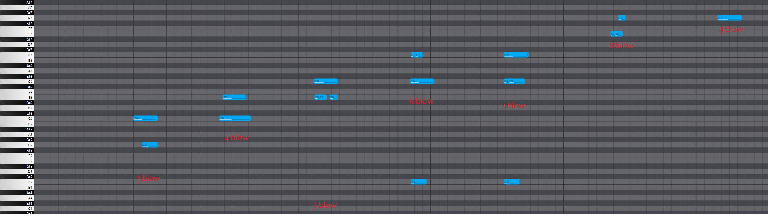

Note 5 blow: 76 and 79 (g5 and e5), take away any in spreadsheet with velocity below 50

Grouping notes

If

Start time and end time of two notes are the same and pitch is the same, merge notes

these could be merged

print(math.isclose(0.626938776, 0.638548753, abs_tol = 0.02))

if math.isclose(endval, startval, abs_tol = 0.02) and pitch_midi is the same

merge notes